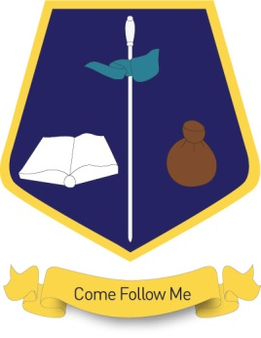

BRITISH VALUES

At St Matthew’s Catholic Primary School we uphold and teach pupils about the British Values as directed under new Ofsted guidance, September 2014.

***‘ ensure that they and the school promote tolerance of and respect for people of all faiths (or those of no faith), cultures and lifestyles; and support and help, through their words, actions and influence within the school and more widely in the community, to prepare children and young people positively for life in modern Britain’***

We value the importance of and support the current Ofsted guidance. As educators we recognise we have a duty to prepare our children for life in modern Britain and to keep them safe.

The British values are:-

* Democracy
* The Rule of Law
* Individual Liberty
* Mutual Respect
* Tolerance of those of different faiths and beliefs

As a Catholic School we actively promote values, virtues and ethics that shape our pupils' character and moral perspective, through the teachings of the Church. We follow the example of the Good Samaritan where we are called to love and care for our neighbour. We ensure that through our school vision, ethos, agreed rules, curriculum and teaching we promote respect and tolerance for all cultures, faiths and lifestyles.

In so doing we reinforce British values regularly and in the following ways:

* Our School Mission Tree which outlines our commitment to a community rooted in love, tolerance, respect and celebration of differences.
* Assemblies and collective worship where we teach respect for all, right and wrong, tolerance and differences and respecting and following the law, in particular through the use of Statements to Live By.
* R.E lessons which teach the children about other faiths as well as their own.
* A range of curriculum topics which have strong links to British History and reflect modern British culture i.e. the Queens Diamond Jubilee, the London Olympics, Victorian Saltaire, etc.
* Linked projects that encourage children to consider similarities and differences between St Matthew’s Catholic Primary School and other schools.
* Our Buddy system for Year 6 and Reception pupils.
* Citizenship responsibilities
* Visits from authorities such as the police, fire service, ambulance service etc. are regular parts of our calendar and help reinforce the rule of law.
* Participation in faith celebrations that reflects our rich ethnic school population and locality community i.e. Flores De Mayo, Chinese New Year, Eid, Diwali.
* Our school motto is used by pupils and staff as a means of repairing harm and developing relationships.
* Our School Council and a democratic system of voting and providing a "voice" for all pupils.
* Theme weeks i.e. Anti-Bullying Week, Remembrance, Internet Safety.
* Pupils are keen to support charities, whether local, national or global i.e. Bradford Food Bank, CAFOD, Children in Need, Royal British Legion.
* Our School Code of Conduct.

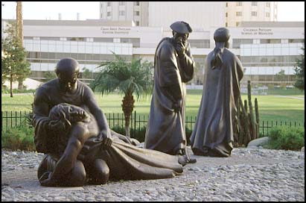

Loma Linda University & Medical Center, California, USA

This contemporary interpretation of the parable in St. Luke's Gospel, The Good Samaritan, speaks of compassion and healing that extends across human barriers of class & racial prejudice.